**Web Login**

***Log Analysis***

**Challenge:**

Can you find the login attempt? Password is the flag.

Attached - web1.pcap

**Approach:**

This one’s quite easy if you know what you’re looking for.

That’s a wireshark capture file so we first open it up on wireshark.

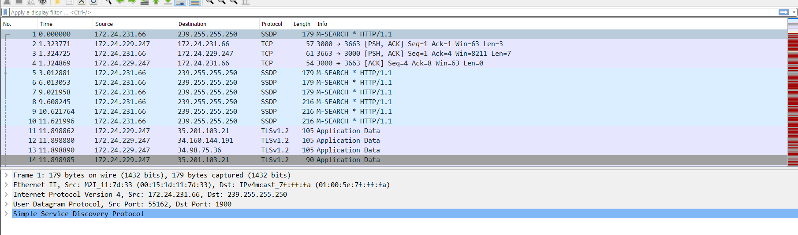

We put up the ‘http’ display filter and sort the ‘Info’ section to look for POST requests (login is better to be done through POST requests)

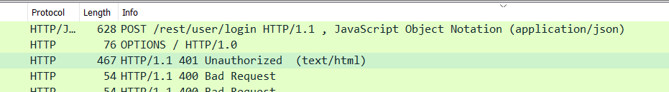

Only one request, yay!

Open it up and we’ll see the password

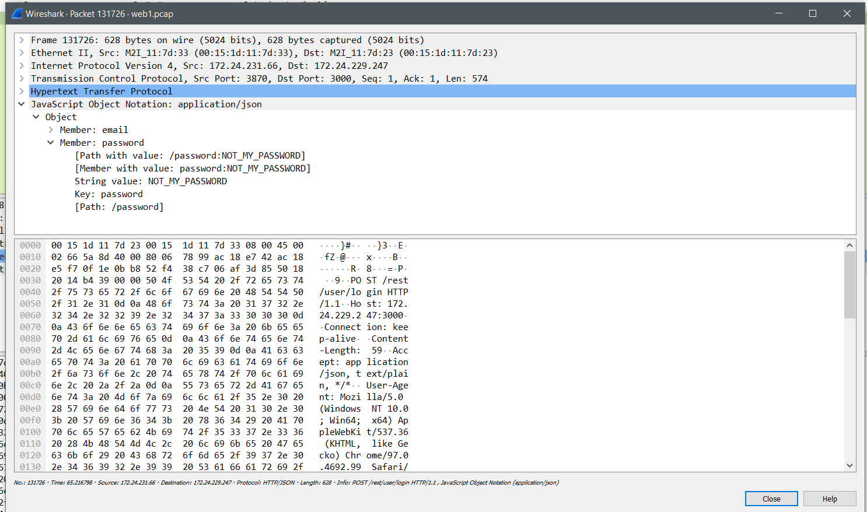

**Flag: NOT_MY_PASSWORD**

Congrats!!

Happy Hacking!